

**COLLEGE OF TECHNOLOGY**

Bsc Project

Implementation Guidelines



Implementation strategy

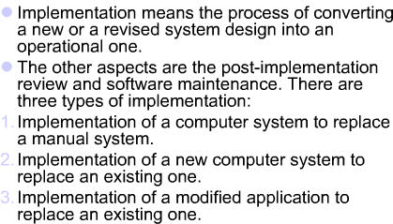



Implementation Phase Deliverables

* Installation & Conversion Plans



* Software and hardware installation,
* Data conversion plan, Site & facility remodeling plan
* Training Plan
* Software maintenance plan



Conversion (Installation)

Conversion is the process of moving from old system to new system Conversion of data must be planned



The aim of conversion is to put the tested system into operation



Activities of conversion

1. **Compile a conversion plan**



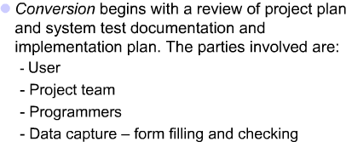



Activities of conversion

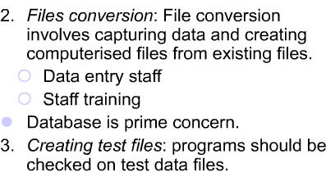



Activities of conversion

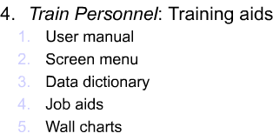



Activities of conversion

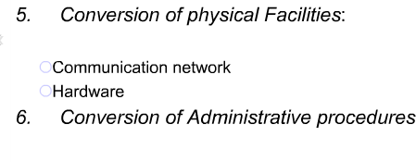



Conversion methods (approaches)



Conversion methods (approaches)

* 1. Direct Installation: Totally change-over.



The old system is turned off when the new one is turned on such that only new system will be operating.

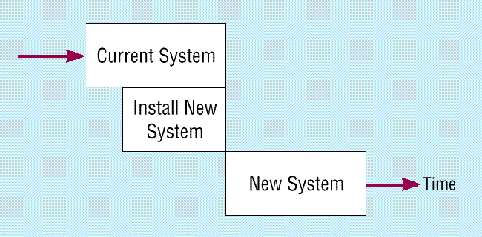



Conversion methods (approaches)

* 1. Parallel Installation: New and old system will be running together for a specific period of time



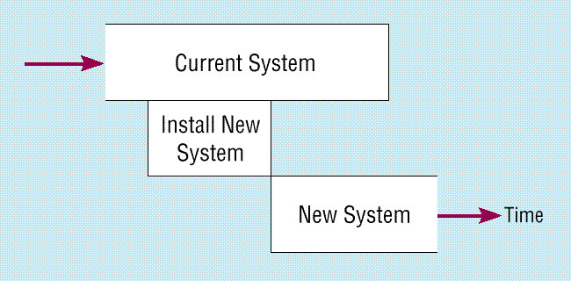



Conversion methods (approaches)

* 1. 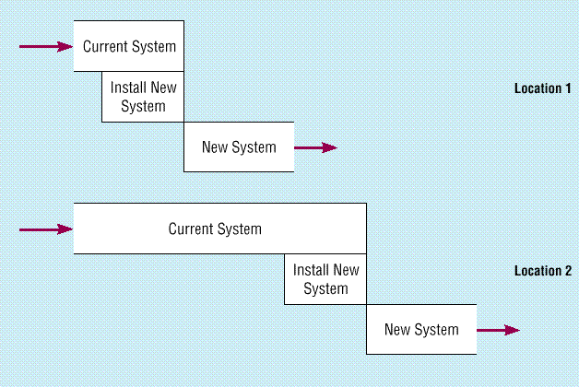Single Location (Pilot) Installation: New information system is installed in one site at time & using the experienced experts to decide how and when the new system should be installed at the other locations/sites of the organization.



Conversion methods (approaches)

* 1. Phased Installation : One module is installed and tested at a time



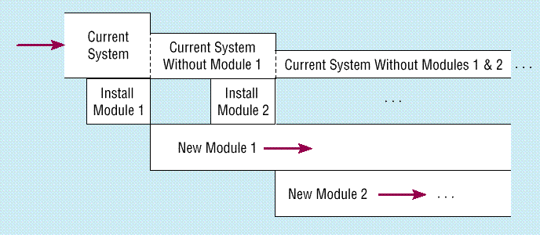



Training plan

* + - Training Tools: Training manual, online help



* + - Training Methodologies:
      * Instructor Led
      * One-on-One
      * User-Led
      * External sources

Resistance to change plan

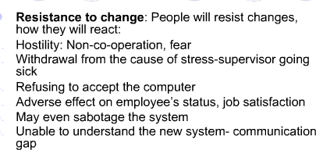

Resistance to change plan

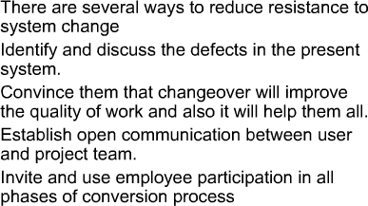



Software maintenance plan

* + - Software maintenance plan specifies the following:



* + - Information Center / Help desk
    - Automating support
    - Resident expert
    - Other things to consider:
      * Providing recovery and backup
      * Disaster recovery
      * PC maintenance



Software maintenance plan

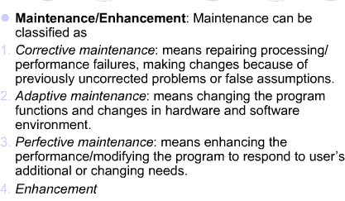



Software maintenance plan

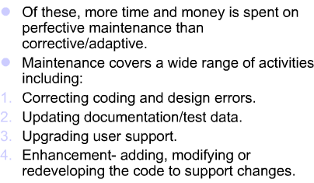



Software maintenance plan

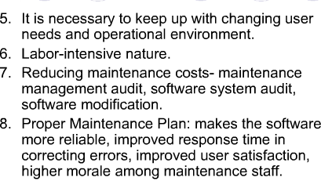

 Supporting the End-user



* Information Center / Help desk
* Automating support
* Resident expert
* Other things to consider:
  + Providing recovery and backup
  + Disaster recovery
  + PC maintenance



Thank you

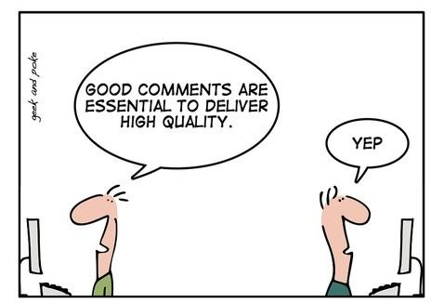

End

Questions